**IS LAB ASSIGNMENT 2**

**COMSATS UNIVERSITY ISLAMABAD**

**(ATTOCK CAMPUS)**

**SUBMITTED BY**

**MISBAH UR REHMAN**

**REGISTRATION NO**

**SP24-BSE-036**

**Graded Task 1 — DES encryption/decryption (use built-in implementation)**

We use PyCryptodome's Crypto.Cipher.DES. DES requires an 8-byte key. We use ECB mode for simplicity and Crypto.Util.Padding to pad plaintext to DES block size. The script prints original plaintext, ciphertext (hex), and decrypted plaintext.

**Code**

# graded_task1_des_example.py

from Crypto.Cipher import DES

from Crypto.Random import get_random_bytes

from Crypto.Util.Padding import pad, unpad

# DES key must be exactly 8 bytes

key = get_random_bytes(8)

def des_encrypt(data: bytes, key: bytes) -> bytes:

cipher = DES.new(key, DES.MODE_ECB)

padded_data = pad(data, DES.block_size)

encrypted_data = cipher.encrypt(padded_data)

return encrypted_data

def des_decrypt(encrypted_data: bytes, key: bytes) -> bytes:

cipher = DES.new(key, DES.MODE_ECB)

decrypted_data = unpad(cipher.decrypt(encrypted_data), DES.block_size)

return decrypted_data

if __name__ == "__main__":

data = b"Secret123" # example plaintext (bytes)

print("Original Data:", data)

encrypted_data = des_encrypt(data, key)

print("Encrypted Data (hex):", encrypted_data.hex())

decrypted_data = des_decrypt(encrypted_data, key)

print("Decrypted Data:", decrypted_data)

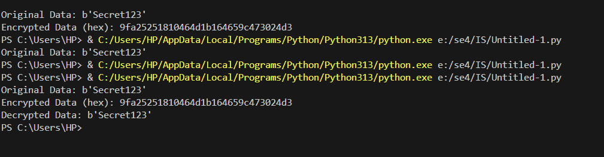

**Graded Task 2**

Double-DES encrypts C = E_{K2}(E_{K1}(P)). Given known (P, C), an attacker can:

1. For each K1 guess compute I1 = E_{K1}(P) and store I1 -> K1.
2. For each K2 guess compute I2 = D_{K2}(C) and look up I2 in stored table.  
   If I1 == I2, (K1, K2) is a candidate key pair. This reduces complexity from O(2^{2n}) to O(2^n) time and memory (for n-bit keys). For demonstration we use **reduced 16-bit** per key (fast on desktop) then expand to 8-byte DES keys to run DES operations.

# graded_task2_mitm_demo_fixed_final.py

"""

Meet-in-the-Middle demo for 2-DES using reduced 16-bit keys for each DES key (demo only).

This version avoids formatting KeyError by escaping braces.

"""

from Crypto.Cipher import DES

import time

# Helper: construct an 8-byte DES key from a 16-bit integer (demo only)

def build_des_key_from_int(k16: int) -> bytes:

    b = k16.to_bytes(2, 'big')

    return b + b + b + b  # 8 bytes total

def des_encrypt_block(key: bytes, block: bytes) -> bytes:

    cipher = DES.new(key, DES.MODE_ECB)

    return cipher.encrypt(block)

def des_decrypt_block(key: bytes, block: bytes) -> bytes:

    cipher = DES.new(key, DES.MODE_ECB)

    return cipher.decrypt(block)

def demo_mitm_reduced_space():

    # 8-byte plaintext block (DES block size)

    P_block = b"ABCDEFGH"

    # True secret reduced keys (16-bit each) for demo

    K1_true_16 = 0x1234

    K2_true_16 = 0xBEEF

    # Build full 8-byte DES keys (demo construction)

    K1_true = build_des_key_from_int(K1_true_16)

    K2_true = build_des_key_from_int(K2_true_16)

    # Compute C = E_{K2}(E_{K1}(P))

    I_true = des_encrypt_block(K1_true, P_block)

    C_block = des_encrypt_block(K2_true, I_true)

    print("MITM demo (reduced 16-bit keys).")

    print("Plaintext block (P):", P_block)

    print("Ciphertext block (C hex):", C_block.hex())

    # Escape braces by doubling them so .format won't treat them as placeholders

    print("True K1_16: 0x{:04X}, True K2_16: 0x{:04X}".format(K1_true_16, K2_true_16))

    # Build forward table for E_{K1}(P)

    max_key = 1 << 16  # 2^16

    table = {}

    t0 = time.time()

    for k1 in range(max_key):

        key1 = build_des_key_from_int(k1)

        I1 = des_encrypt_block(key1, P_block)

        # store first seen k1 for this intermediate value

        if I1 not in table:

            table[I1] = k1

    t1 = time.time()

    # Use escaped braces in the message ({{ and }}) so .format doesn't look for 'K1'

    print("Built table for E_{{K1}}(P) over 2^16 keys in {:.2f} seconds".format(t1 - t0))

    # Now try K2 guesses: compute D_{K2}(C) and lookup

    found = []

    t2 = time.time()

    for k2 in range(max_key):

        key2 = build_des_key_from_int(k2)

        I2 = des_decrypt_block(key2, C_block)

        if I2 in table:

            k1_candidate = table[I2]

            found.append((k1_candidate, k2))

            # break when true pair found (optional)

            if k1_candidate == K1_true_16 and k2 == K2_true_16:

                break

    t3 = time.time()

    print("Searched K2 space in {:.2f} seconds".format(t3 - t2))

    print("Found candidate key pairs (k1_16, k2_16):", [(hex(a), hex(b)) for a,b in found])

    # Verify the first found candidate by doing full double-encrypt

    if found:

        k1_test_16, k2_test_16 = found[0]

        k1_test = build_des_key_from_int(k1_test_16)

        k2_test = build_des_key_from_int(k2_test_16)

        i_test = des_encrypt_block(k1_test, P_block)

        c_test = des_encrypt_block(k2_test, i_test)

        print("Verification: Re-encrypted ciphertext matches C?:", c_test == C_block)

    else:

        print("No candidate keys found (unexpected in demo).")

if __name__ == "__main__":

    demo_mitm_reduced_space()

